Cse370 Lab Assignment 02

Deadline: 26-06-2023 11:59 pm

Name: Ms Rodsy Tahmid

Id: 20101021

Sec-06

mysql -u root -p

use lab_hw1;

show databases;

show tables;

select * from developers;

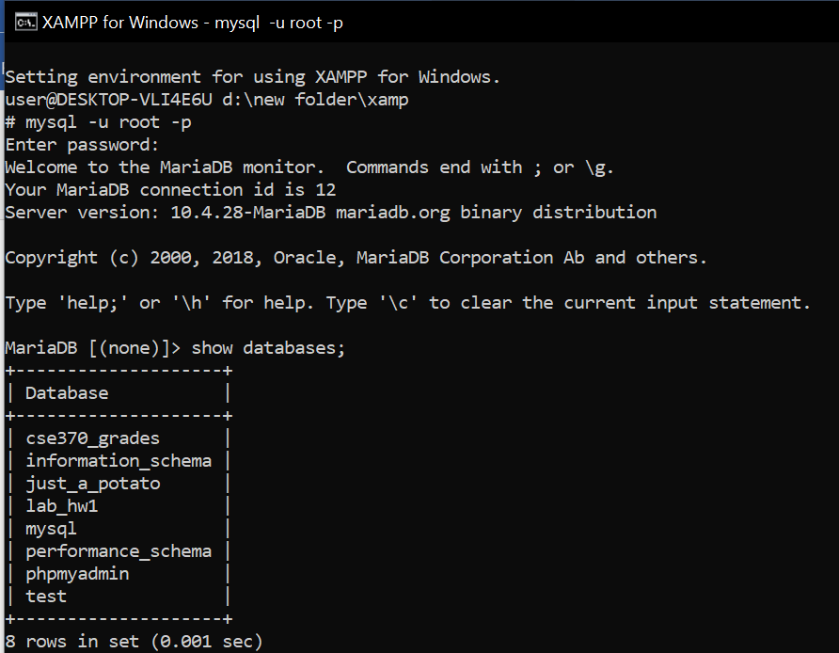

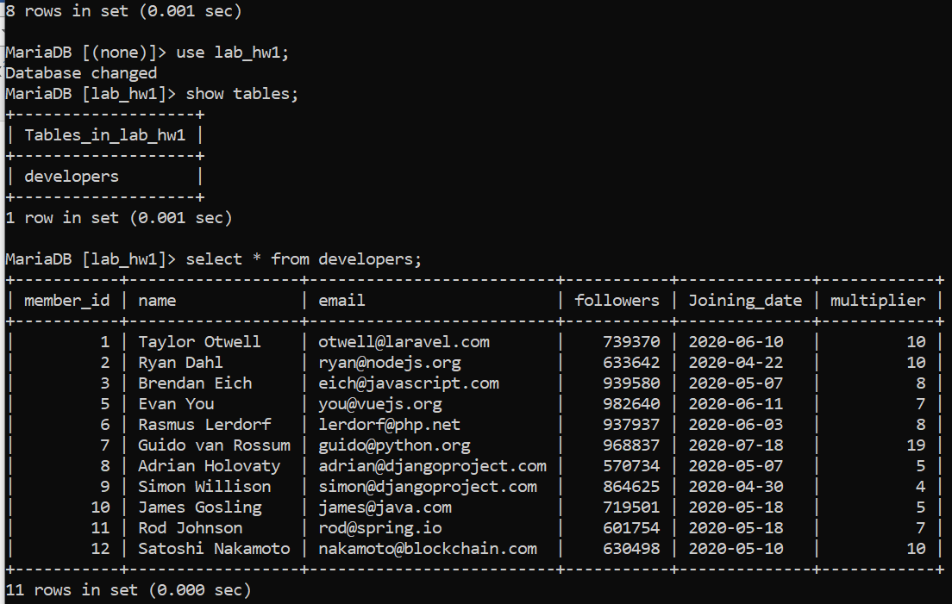

#Task-1:

select distinct joining_date from developers order by joining_date;

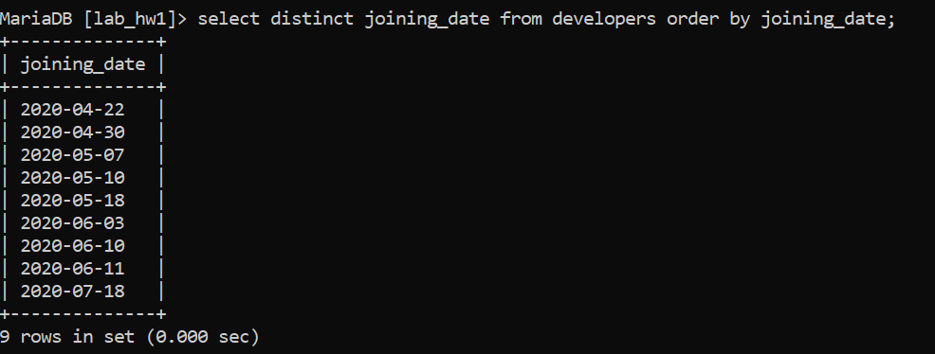

#Task-2:

select name, email from developers order by followers desc limit 5;

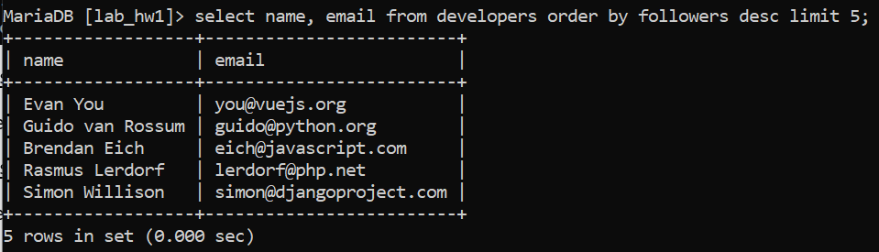

#Task-3:

select multiplier, count(*) as no_of_developers from developers group by multiplier;

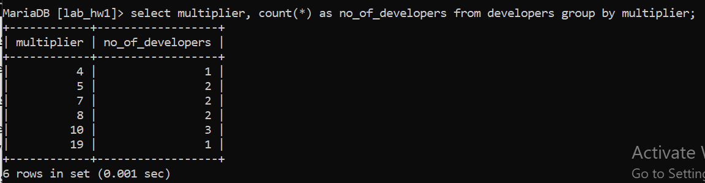

#Task-4:

select name from developers where followers < 700000 and multiplier in (select max(multiplier) from developers where followers < 700000);

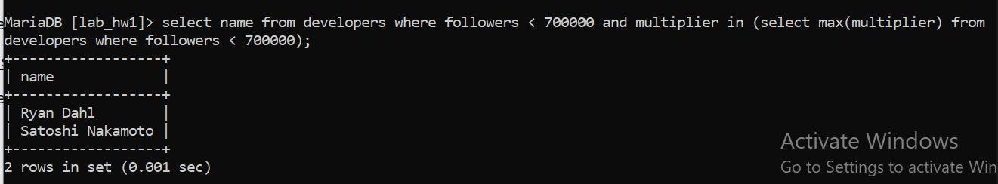

#Task-5:

select avg(followers) as avg_no_of_followers from developers where joining_date < '2020-06-11';

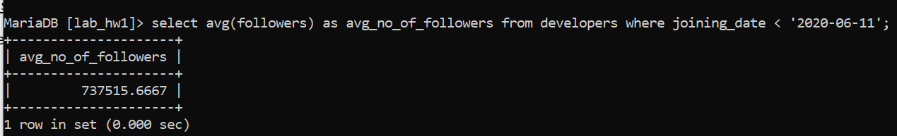

#Task-6:

select member_id, name, email, followers from developers where email like '%.com' or email like '%.net';

